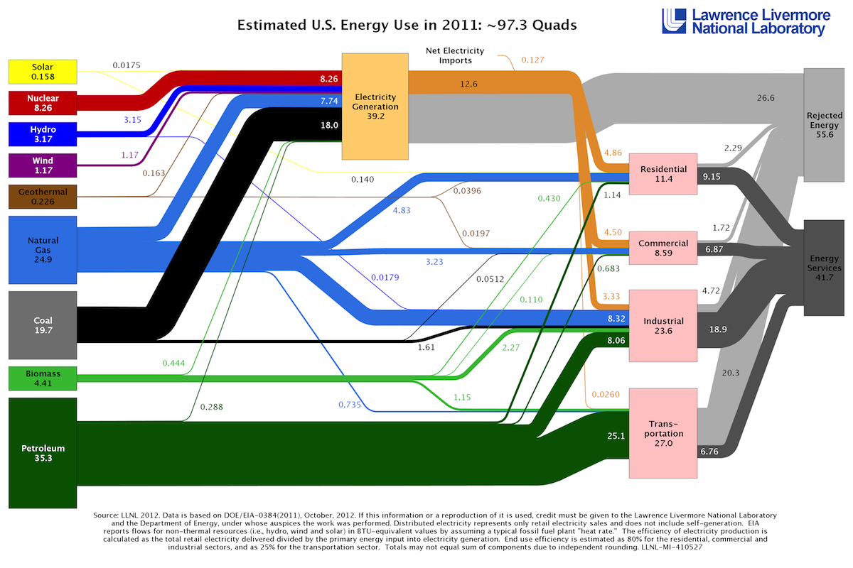
1- Based on the LLNL energy flow figure, reproduced below, [x1] quads of coal energy were used to produce electricity in the US in 2011.

Answer: ______93.7 Quads________
INCORRECT

2- Based on the LLNL energy flow figure, reproduced below, [x1] quads of natural gas energy were used for residential applications in the US in 2011.

Answer: ___93.7 Quads_______
INCORRECT

For the following reaction:
3 CO + 7 H₂ → C₃H₈ + 3 H₂O
This reaction is:
exothermic

endothermic INCORRECT

both

neither

3- For the following reaction:

3 CO + 7 H₂ → C₃H₈ + 3 H₂O
The reaction is called:
water-gas production reaction

water-gas shift reaction

Fischer-Tropsch process

steam methane reforming

4- How much CO₂ in metric tonnes is produced by the combustion of 440 metric tonnes of propane (C3₃H8₈)?
Solution
INCORRECT
the mol ratio is
3 mol of CO2 per 1 mol of C3H8
then
mol C3H8 = mass/MW = 440/44.1 = 9.97732 ton-mol
then
CO2 = 3*9.97732 = 29.93196 ton of CO2
nearest answer is
less than 1000

Less than 1000

1000-1100

1100-1200

1200-1300

1300-1400

1400-1500

More than 1500

5- What is the Carnot efficiency of an engine if the heat source is 600˚C and the heat sink is 25˚C?
Solution
Equation:
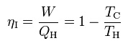
n_{i}, maximum efficiency of the engine
W, the work done by the system (energy exiting the system as work)
Q_{H}, the heat put into the system (heat energy entering the system)
T_{C}, absolute temperature of the cold reservoir.
T_{H}, absolute temperature of the hot reservoir.
T_{C} = 298 K (25ºC in K)
T_{H} = 873 K (600ºC in K)
ni = 1 – (298 K/873 K)
ni = 0.66*
*to convert in percent (%), just multiply by 100
Answer (66 %)
Between 60 % and 70 %.

Less than 30%

Between 30% and 40%

Between 40% and 50%

Between 50% and 60%

Between 60% and 70%

Higher than 70%

6- Consider the previous reaction. How many grams of CO₂ are produced?
Less than 50

50-80

80-110

110-140

More than 140

7- Which of the following would be considered biofuels?
PARTIAL CORRECT
Trash

Corn Ethanol

Cellulosic Ethanol

Biodiesel

Soybean oil

Wood pellets

Biogas from a landfill

